DAD 220 Project One Template

Complete these steps as you work through the directions for Project One. Replace the bracketed text with your screenshots and brief explanations of the work they capture. Each screenshot and its explanation should be sized to approximately one-quarter of the page with the description written below the screenshot. Follow these rules for each of the prompts and questions below. Review the example document in the Supporting Materials section of the Project One Guidelines and Rubric for assistance.

Step One: Create a Database

- In your online IDE (Codio), create a database schema called QuantigrationUpdates that will hold tables by using SQL commands.
  - List out the database name on the screen.
  - Provide the SQL commands you ran against MySQL to complete this step.
The SQL commands I used where
Create Database QuantigrationUpdates;

And then used the SQL commands
Describe databases to show all the databases including the one just created

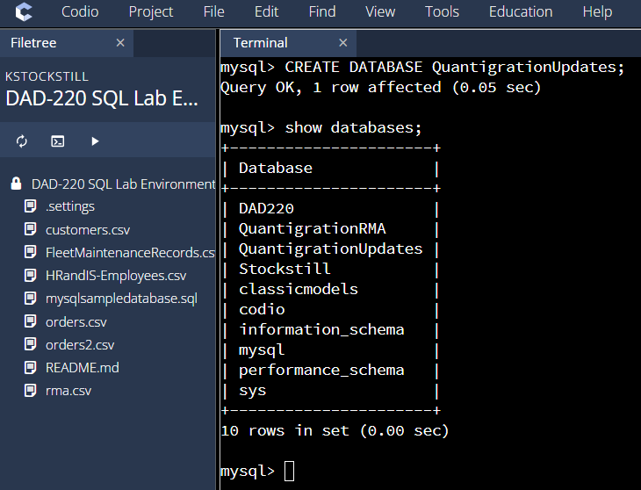

- Connect to the QuantigrationUpdates schema. Using the ERD as a reference, write SQL commands to create the following tables with the appropriate attributes and keys to demonstrate relationships based on the ERD.
  - A table named Customers to store customer information with a primary key of Customer ID. Provide the SQL commands you ran against MySQL to complete this step.

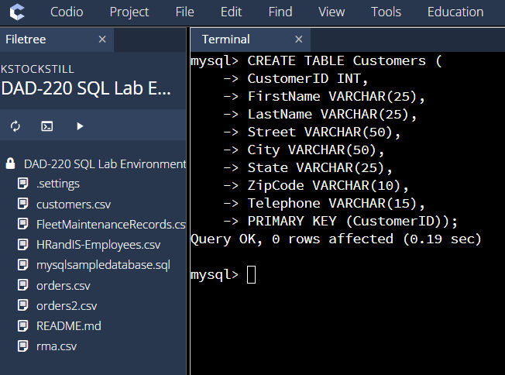

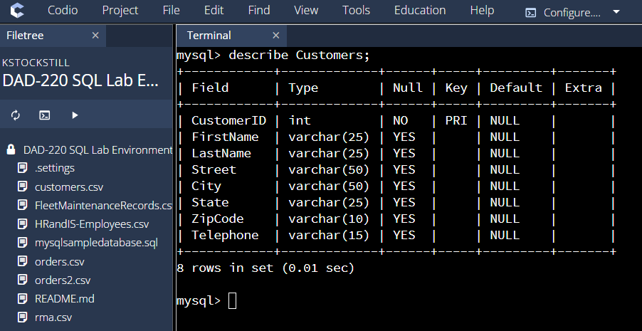

I used the create table SQL command to create a table called Customers and included all the rows in the table.
CREATE TABLE Customers
CustomerID INT
FirstName VARCHAR(25)
LastName VARCHAR(25)
Street VARCHAR(50)
City VARCHAR(50)
State VARCHAR(25)
ZipCode VARCHAR(10)
Telephone VARCHAR(15)
PRIMARY KEY (CustomerID)

I then used the describe Customers to show the complete table I had created

  - A table named Orders to store order information with a primary key of Order ID and a foreign key of Customer ID. Provide the SQL commands you ran against MySQL to complete this step.

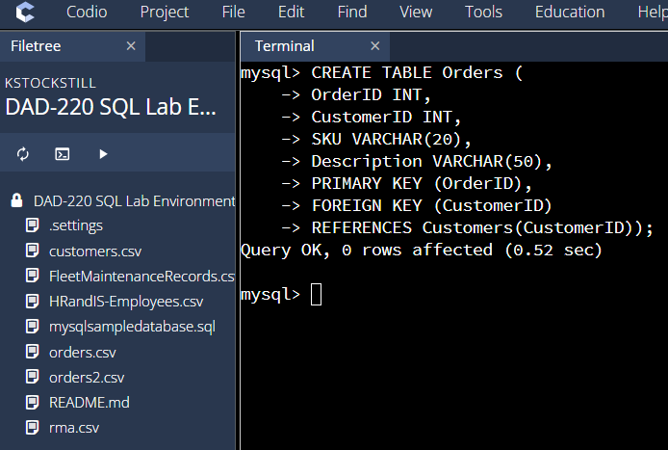

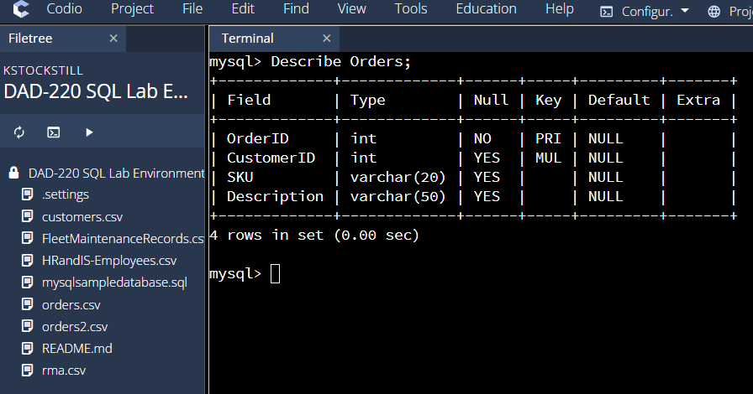

I used the CREATE TABLE Orders
OrderID INT
CustomerID INT
SKU VARCHAR(20)
Description VARCHAR(50)
PRIMARY KEY (OrderID)
FOREIGN KEY (CustomerID)
REFERENCES Customers(CustomerID)
Then I used the describe Orders to show the completed table

  - A table named RMA to store RMA information with a primary key of RMA ID and a foreign key of Order ID. Provide the SQL commands you ran against MySQL to complete this step.

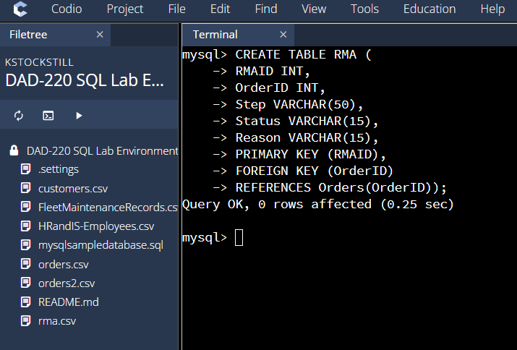

Used CREATE TABLE RMA
RMAID INT
OrderID INT
Step VARCHAR(50)
Status VARCHAR(15)
Reason VARCHAR(15)
PRIMARY KEY (RMAID)
FOREIGN KEY (OrderID)
REFERENCES Orders(OrderID)

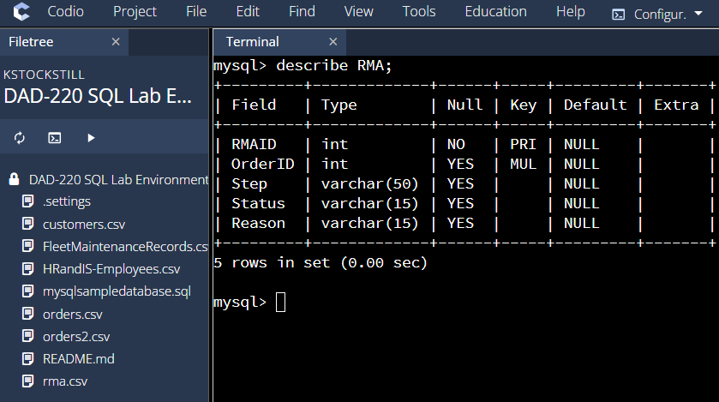
Used describe RMA to show the complete RMA table
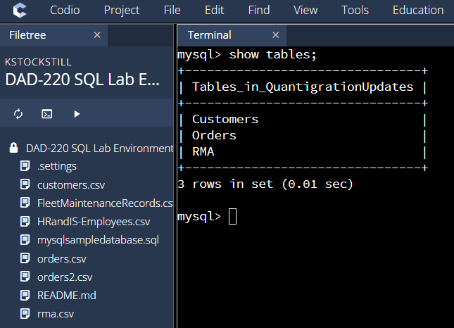

I used SHOW TABLES to show all of the tables in the QuantigrationUpdates database

Step Two: Load and Query the Data

- Import the data from each file into tables.
  - Use the QuantigrationUpdates database, the three tables you created, and the three CSV files preloaded into Codio.
  - Use the import utility of your database program to load the data from each file into the table of the same name. Perform this step three times, once for each table.
  - Provide the SQL commands you ran against MySQL to complete this step.

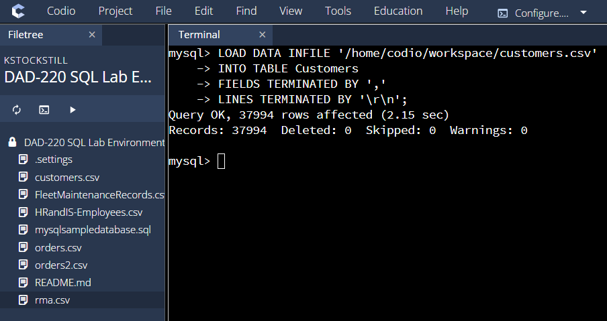

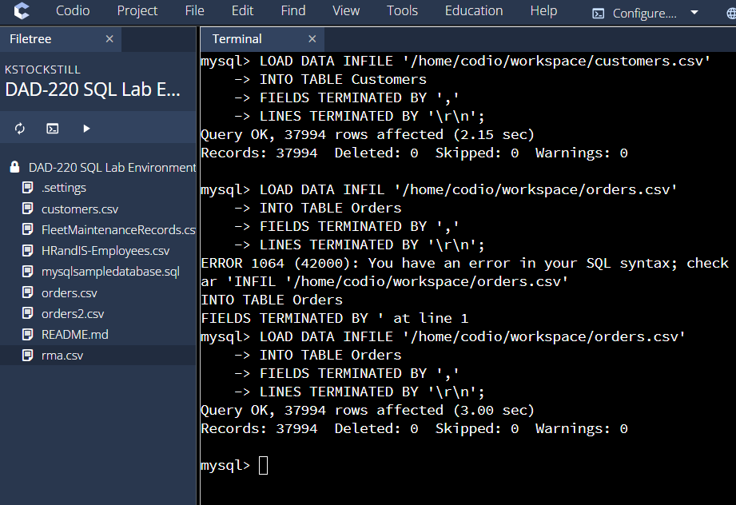

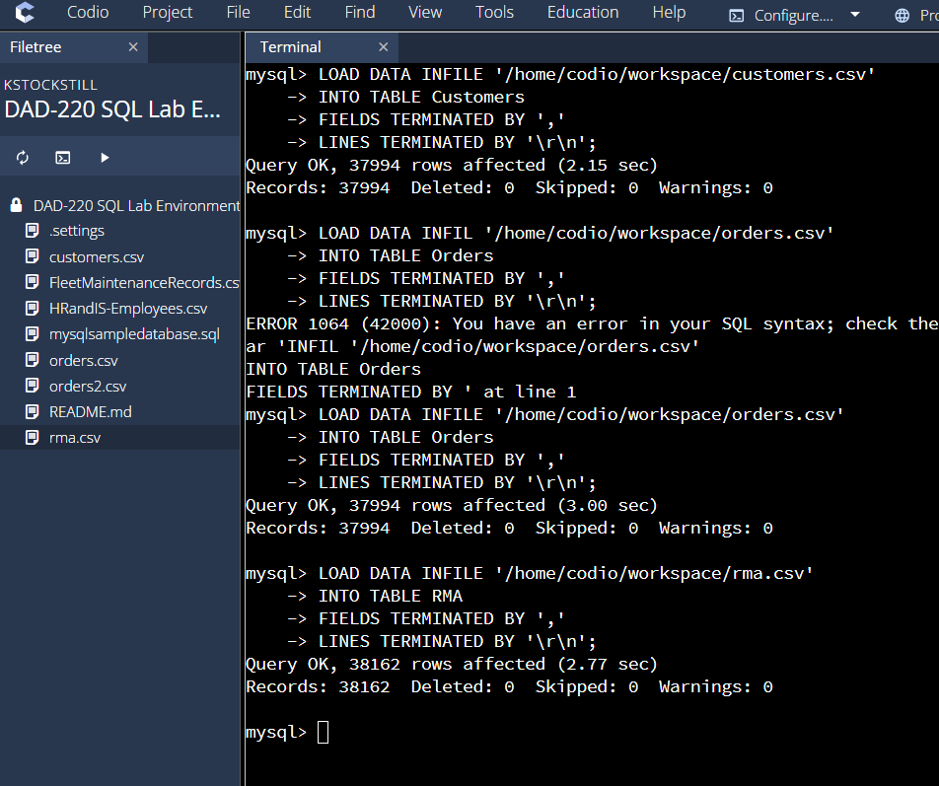

I loaded in the csv files into each specific tables that I created

I used the SQL command
LOAD DATA INFILE ‘/home/codio/workspace/orders.csv
INTO TABLE Orders
FIELDS TERMINATED BY ‘,’
LINES TERMINATED BY ‘\r\n’

And

LOAD DATA INFILE ‘/home/codio/workspace/rma.csv
INTO TABLE RMA
FIELDS TERMINATED BY ‘,’
LINES TERMINATED BY ‘\r\n’

And lastly

LOAD DATA INFILE ‘/home/codio/workspace/customers.csv
INTO TABLE Customers
FIELDS TERMINATED BY ‘,’
LINES TERMINATED BY ‘\r\n’
After making all of these SQL load data inquiries all of the required information was loaded into the correct tables.

- Write basic queries against the imported tables to organize and analyze the targeted data. For each query, replace the bracketed text with a screenshot of the query and its output. Also, include a one- to three-sentence description of the output.
  - Write a SQL query that returns the count of orders for customers located only in Framingham, Massachusetts.
    - This query will use a table join between the Customers and Orders tables. The query will also use a WHERE clause.
    - How many records were returned?

I inner joined the customerID on the Customers table and the Orders and included the city or Framingham and the State of Massachsetts to get the count of 505 customers

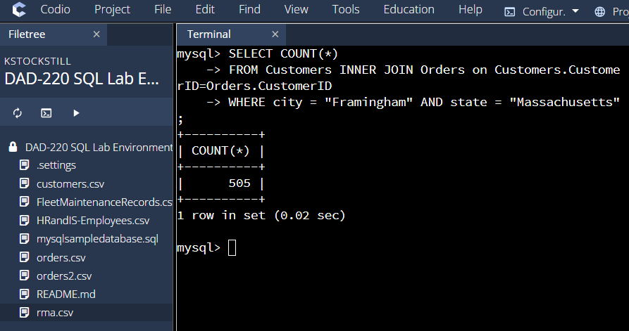

  - Write a SQL query to select all of the customers located in Massachusetts.
    - Use a WHERE clause to limit the number of records in the Customers table to only those who are located in Massachusetts.
    - How many records were returned?

I counted all customers that are in the Customers table that where located in the state Massachusetts and got back a result of 982 customers

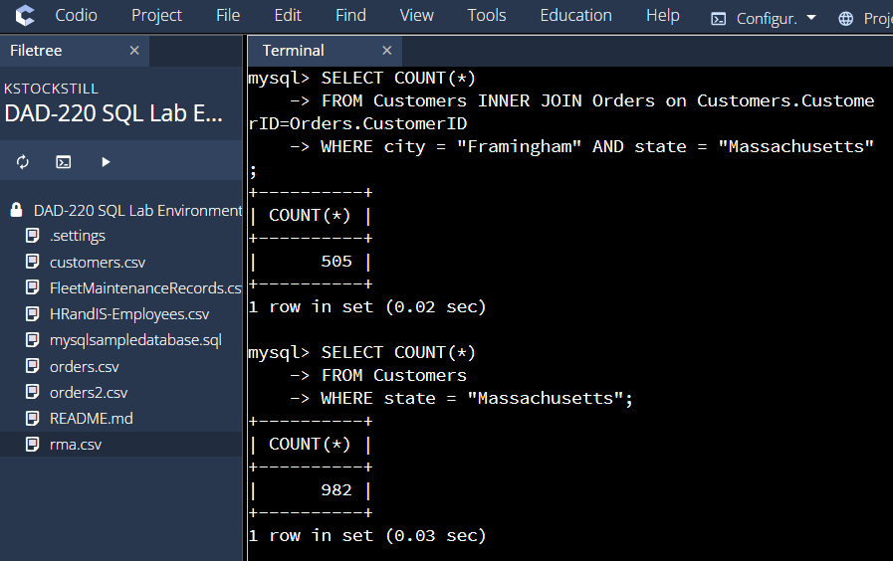

  - Write a SQL query to insert four new records into the Orders and Customers tables using the data below:

Customers Table
CustomerID | FirstName | LastName | StreetAddress | City | State | ZipCode | Telephone
100004 | Luke | Skywalker | 15 Maiden Lane | New York | NY | 10222 | 212-555-1234
100005 | Winston | Smith | 123 Sycamore Street | Greensboro | NC | 27401 | 919-555-6623
100006 | MaryAnne | Jenkins | 1 Coconut Way | Jupiter | FL | 33458 | 321-555-8907
100007 | Janet | Williams | 55 Redondo Beach Blvd | Torrence | CA | 90501 | 310-555-5678

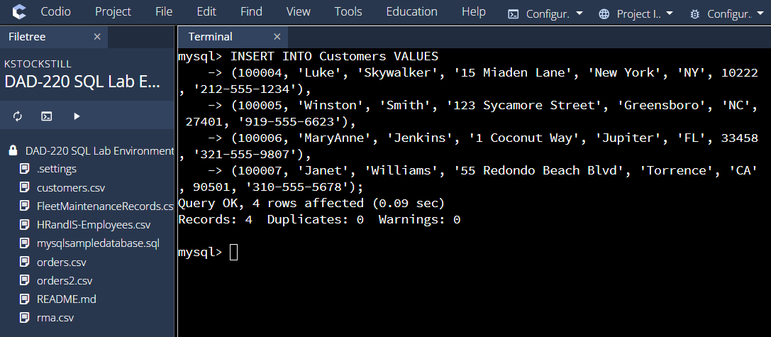

I inserted 4 new cutomers into the Customers table by using the INSERT INTO command
I wrote the new insert in the order of how they would be read on the table; CustomerID, FirstName, LastName, Street, City, State, ZipCode, Telephone.

Orders Table
OrderID | CustomerID | SKU | Description
1204305 | 100004 | ADV-24-10C | Advanced Switch 10GigE Copper 24 port
1204306 | 100005 | ADV-48-10F | Advanced Switch 10 GigE Copper/Fiber 44 port copper 4 port fiber
1204307 | 100006 | ENT-24-10F | Enterprise Switch 10GigE SFP+ 24 Port
1204308 | 100007 | ENT-48-10F | Enterprise Switch 10GigE SFP+ 48 port

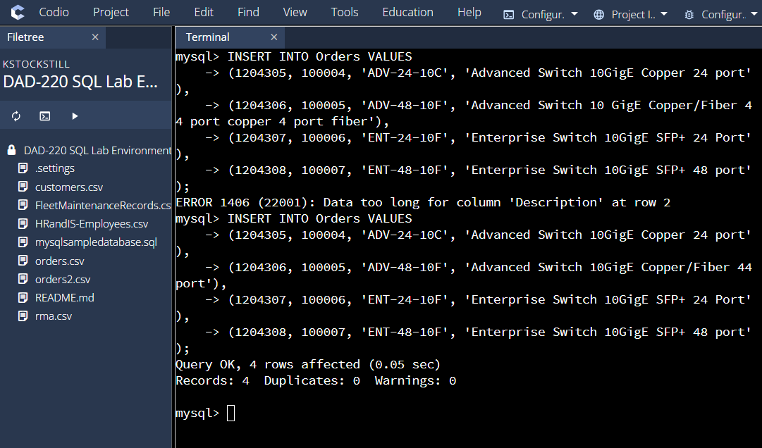

I again used the INSERT INTO SQL command to insert 4 new Order information into the Orders Table; I also wrote in the correct order of OrderID, CustomerID, SKU, Description. This inserted 4 new orders that corresponded to the 4 new Customers I previously added.

  - In the Customers table, perform a query to count all records where the city is Woonsocket and the state is Rhode Island.
    - How many records are in the Customers table where the field "city" equals "Woonsocket"?

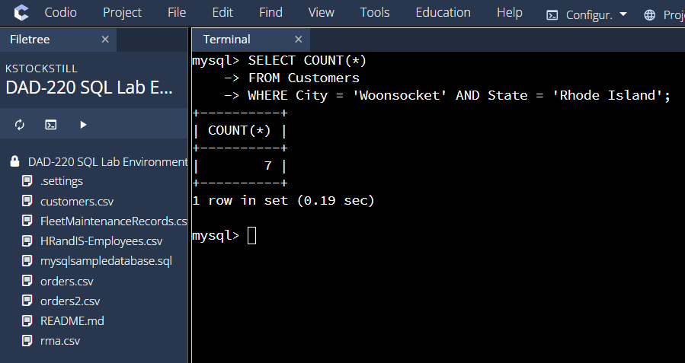

I was able to count all of the customers from the Customers table that where in the city Woonsocket from the state of Rhode Island and got a return of 7 customers.

  - In the RMA database, update a customer's records.
    - Write a SQL statement to select the current fields of status and step for the record in the RMA table with an OrderID value of "5175".
      - What are the current status and step?

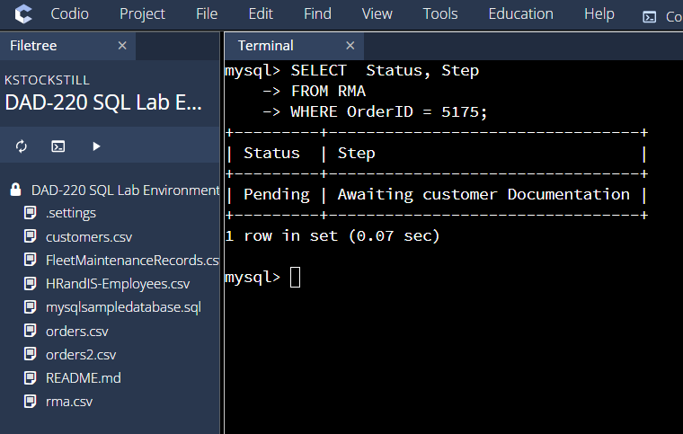

I selected Status and Step from the RMA table to specifiy with the OrderID of 5175. With this I got the return of a pending status and a step that was awaiting customer Documentation.

    - Write a SQL statement to update the status and step for the OrderID, 5175 to status = "Complete" and step = "Credit Customer Account".
      - What are the updated status and step values for this record?

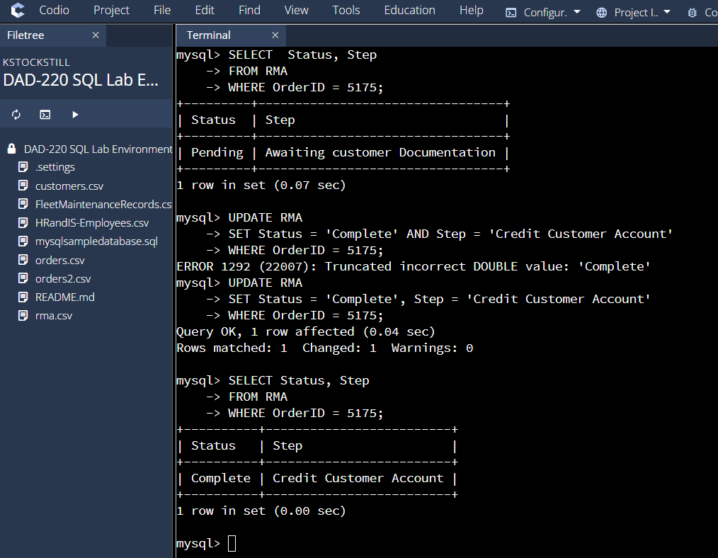

I updated the status to complete and also the step to credit customer account in the table RMA where the OrderID was 5175. Once completed I used the select status and step from RMA where the OrderID was 5175 to show the updated states of said OrderID.

  - Delete RMA records.
    - Write a SQL statement to delete all records with a reason of "Rejected".
      - How many records were deleted?

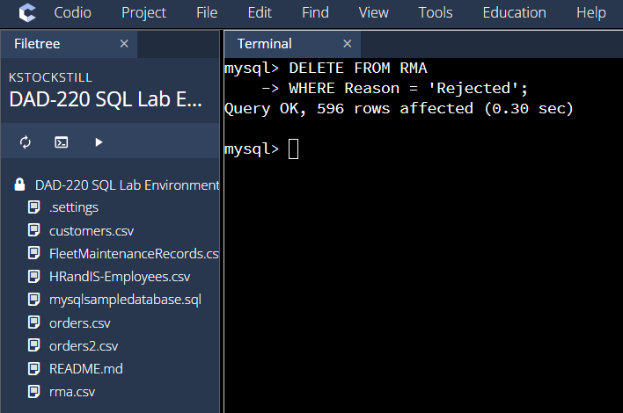

I used the DELETE SQL command to deleted from the RMA table all of the rejected reasons. This came back with a return of 596 rows deleted.

- Update your existing tables from "Customer" to "Collaborator" using SQL based on this change in requirements. Copy and paste the SQL you write to do the following action:
  - Rename all instances of "Customer" to "Collaborator".

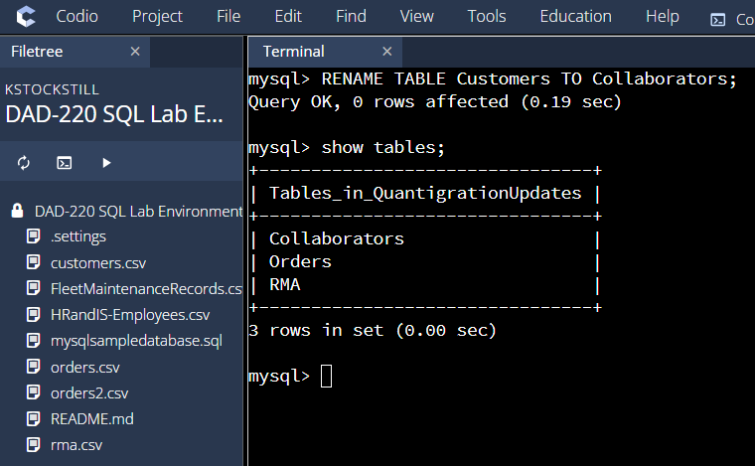

I first started by changing the name of the Customers table to Collaborators. With the Rename Table SQL command. And then used the show tables to show that they table name was correctly changed.

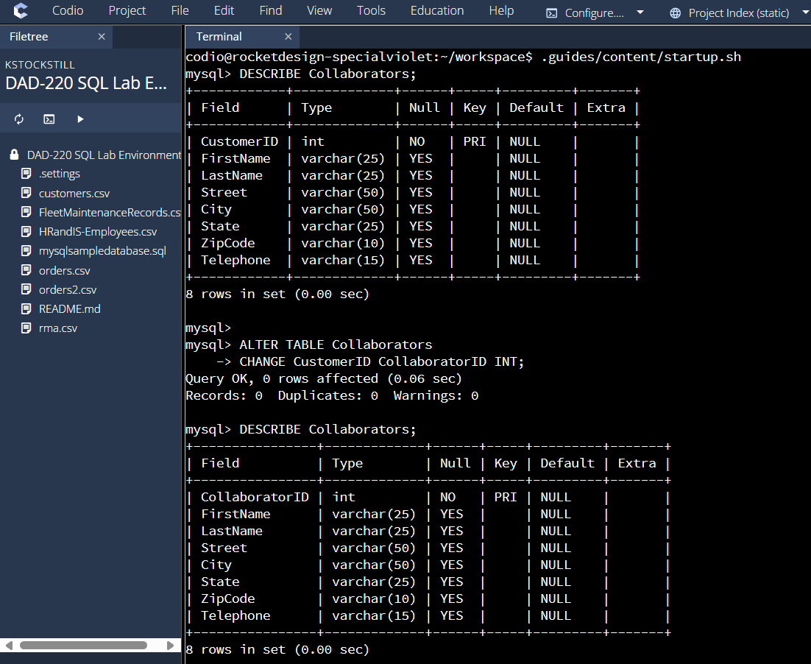

I then Altered the table Collaborators and changed the CustomerID to CollaboratorID
Then I described the table Collaborators to show that CustomerID was successfully changed to CollaboratorID

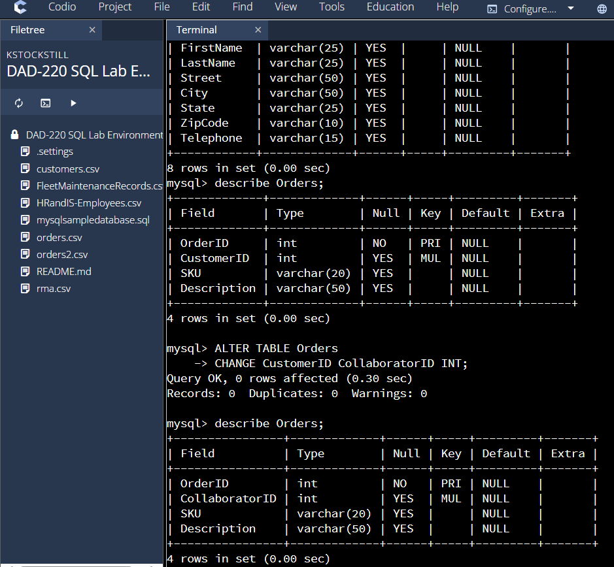

I then went and altered the table of Orders and changed the CustomerID to CollaboratorID. I used describe Orders to again show that CustomerID was successfully changed to CollaboratorID. After completing this All CustomerID have been changed to CollaboratorID.

- Create an output file of the required query results. Write a SQL statement to list the contents of the Orders table and send the output to a file that has a CSV extension.

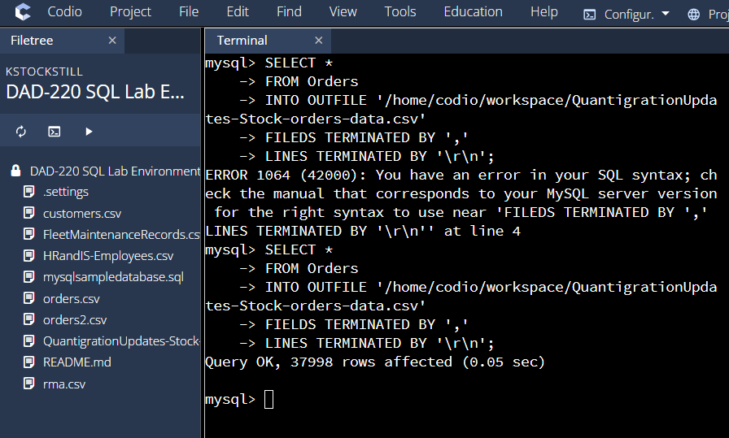

I selected all from the Orders table to put into an Outfile by the name of QuarntgrationUpdates-stock-orders-data.csv. Once completed you can see on the left side that said output file was successful.

